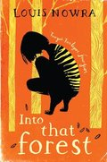
- Into That Forest, Louis Nowra
KS4 Recommended reading
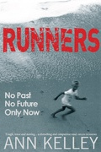

- Runners, Ann Kelly
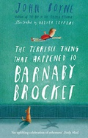

- The Terrible Thing That Happened to Barnaby Brocket, John Boyne

- Jane Eyre, Charlotte Brontë

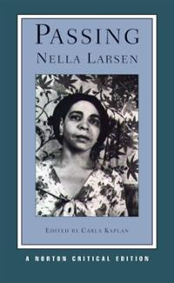

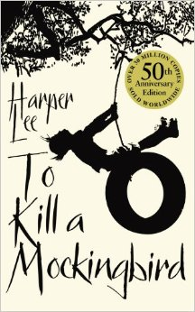
- Passing, Nella Larsen

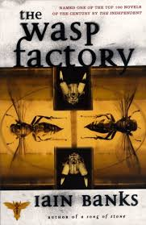
- To Kill a Mockingbird, Harper Lee

- The Wasp Factory, Iain Banks

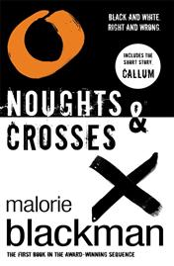

- Noughts and Crosses, Malorie Blackman
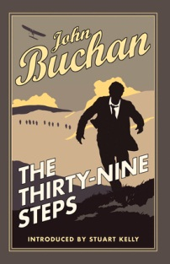

- The Thirty-Nine Steps, John Buchan
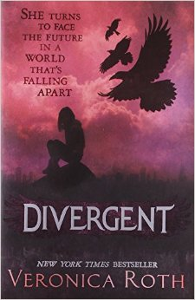
- Divergent, Veronica Roth

